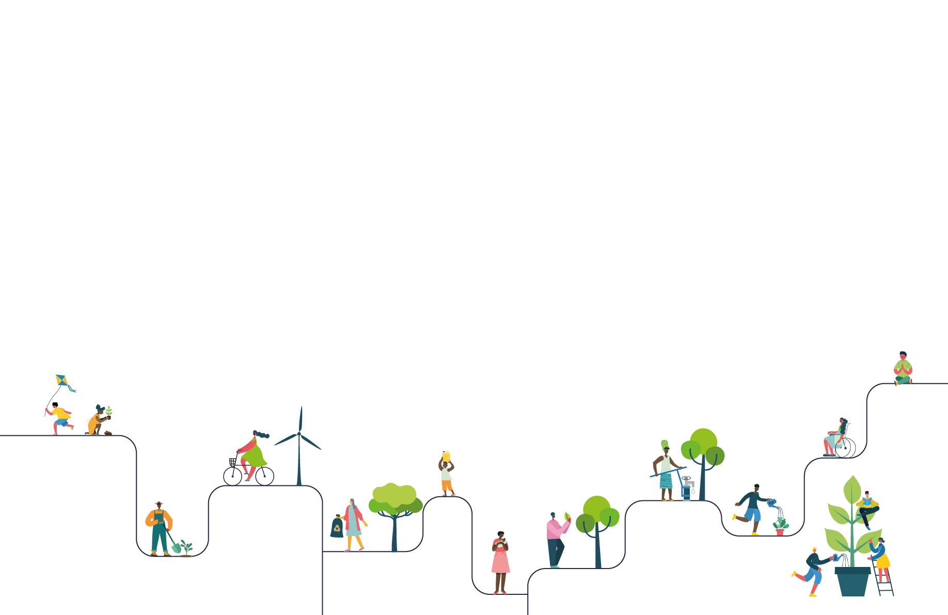



SCHOOL NAME: St Mary's RC Primary School
CONTACT NAME : Carole Priestner

Thank you for registering your LiveSimply action plan.
The details you entered online are listed below.
Should you have any queries, please visit cafod.org.uk/LiveSimplySchools for the FAQs


Your LiveSimply action plan Carole a3RQ2000000IBwHMAW
Global Actions
Action 1 Living in Solidarity main action
1A) ___ We will take part in the CAFOD Big Lent Walk. The whole school will take part in a sponsored walk to raise funds for, and awareness of, CAFOD's work in supporting our global family. (Living in Solidarity)
Global Faith element 1
We will learn as a school about Lent and it being a time of reflection and also about CAFOD and their work with the Global Family to fight poverty. This will be done through assembly time and class RE and collective worship sessions.
The children will all take part in the Big Lent Walk and raise money for CAFOD through donations on the day.
This event will include the whole school family and members of the church, community and our families will be invited to join in with the walk.
Global Learning element 1
The children will gain an understanding of the work of CAFOD to help fight poverty oversees.
The children will use the CAFOD website and resources to explore examples of how people have been helped and the impact that it has had on their lives.
Website - walk.cafod.org.uk

How will you involve the wider community taking part in the action i.e. governors/families/parishioners/local people
The whole school from Nursery to Year 6 will be involved in the walk which will take place on the school field track.
Parents, church members and local community members will be invited to join in - this information will be provided via the school and parish newsletters and also on our school Facebook account.
Adults will be invited to stay and have refreshments at the end of the event (with a donation to raise further funds)

Would you like a CAFOD visitor to deliver an assembly/workshop to support your CAFOD fundraising action? No visit is required

Action 2
2A) ___ We will speak out against global injustices (e.g. global food system, debt, climate) by taking part in current CAFOD campaign actions to stand in solidarity with our global (overseas) community. (Living in Solidarity)
Global Faith element 2
The school will take part in the Big Green Week.
Pope Francis reminds us that we all have a part to play to top the climate crisis harming our global family.
(Laudate Deum)
The children will learn ways to help our environment through the ways we reduce, reuse and recycle.
7th - 15th June 2025
Global Learning element 2
The children will explore different ways that they can reduce, reuse and recycle in order to impact the climate situation and global warming.
They will use the CAFOD resources online to research the possible ways that the school can change to help the situation and also how to encourage changes at home.
The children will look at ways to improve our environment in school and at home. Each class will take part in some activities and will send home the message on some ways to improve our environment.
It's great to hear you will be participating in Big Green Week, in addition please ensure you are able to participate in one of the CAFOD campaign actions or include writing to your local MP/Parliament to ensure the world’s poorest communities are kept at the centre of discussions as they most often face injustice and inequality. As this is a global action it needs to have a direct impact on our global community and the pupils using their voices to speak out against injustice and raise those concerns to members of parliament who can help act is a way to take direct action. The campaigns resources can be found on the link below, and we also hope to have an action regarding debt for the Jubilee Year which you may like to participate in.
https://cafod.org.uk/education/campaign-in-your-school

Action 3
3B) ___ We will take part in World Day of the Poor. Included within our actions for this day, pupils will write prayers for the world's poorest communities. (Living Simply)
Global Faith element 3
Luke 6: 21-22, Jesus says "Blessed are the you who are poor, for yours is the Kingdom of God". He promises that the poor will inherit something far greater than any of the riches of the world.
The children will focus on the poor of the world on World Day of the Poor
November 17th 2024
Global Learning element 3
The children will learn about ways that we can support the poor via World Day of the Poor.
The children will be asked to write prayers for the world's poorest communities to share with their classes and display to remind us to think of others who are not so lucky as we are.
Local Actions
Action 1
1C) ___ Pupils will host events in our school for older members of our parish/local community to visit our school to foster understanding between the generations (e.g. afternoon teas, a show, chat and craft, gardening hour, simple soup lunch). (Living Simply)
Local Faith element 1
The children will learn about our school community and the wider parish and local communities. They will learn how we are all a family who can learn from each other and enjoy each others company.
Local Learning element 1
The children will design, create and send invitations to the parish and local sheltered housing to invite them to attend our school events throughout the year, such as
* The Macmillan coffee morning.
* EYFS and KS1 Christmas productions.
* KS2 Easter production
* End of term Mass celebrations
In this way they are able to share the events with the school and to foster an appreciation and understanding of different generations within our parish and local community.

Action 2
2B) ___ Pupils will work to support the local community in a variety of ways (e.g. praying, cards of kindness, supporting the lonely. (Living Simply)
Local Faith element 2
The children will learn through assembly time and class lessons about Harvest time and the importance of sharing our food so everyone has enough.
The children will be invited to attend a Harvest Mass to celebrate with the parish and show the donations they have gathered. They will be included within the Mass through bidding prayers, offertory procession and singing songs learnt in school.
Local Learning element 2
Children will be encouraged to collect food at harvest time to be donated to the local food bank.
They will learn about why this is necessary and how food banks work.
The children will create artwork and prayers to celebrate the Harvest and to think of others who do not have enough food in our local area.

Action 3
3C) ___ We will support our local homeless shelter. Pupils will find out what the shelter needs and then raise funds or gather the items required. (Living in Solidarity)
Local Faith element 3
Children will learn about others who are less fortunate than themselves and understand how we can help and support them.
Parable of the Good Samaritan
Local Learning element 3
Children will take part in Wrap Up UK to collect coats for local homeless people.
They will learn about this initiative through the Wrap Up UK website.
The school council will take the lead in collecting and storing coats that have been donated and helping on the collection day.
October/November 2024

School Actions
Action 1 – Living Simply main action
1B) ___ We will hold a whole school art or photography competition, celebrating awe and wonder of God's creations. Depending on the age group we will either provide quotations from scripture to inspire the pupils, or they will choose one themselves to go with their art/photo. (Living simply)
School Faith element 1
The children will learn about Gods Wonderful World on Earth Day and explore all of God's creations.
They will be able to relate this to the RE lessons in the Creation and Covenant topic - based on the creation of our world: Genesis and a variety of psalms celebrating the word of God.
School Learning element 1
There will be a whole school focus on God's world on Earth Day with lessons including writing, artwork and prayers to celebrate God's creations and to celebrate the awe and wonder of these.
The children will share their work and their understanding of this day in a whole school assembly.
The children will produce a whole school display to show their work to others within the school and those who visit.

How will the school be involving the wider community in their Living Simply action
The parents will be invited to a whole school assembly to share the work produced for this action and the message of how we can appreciate and look after our world.
The work will be displayed within the school to show our appreciation of our world.
The work produced will be shared on social media to exhibit what the children have learnt and created.

Action 2 – Living Sustainably main action
2A) ___ We will develop a culture of buy less, share more (e.g. pupils will hold pre-loved book/toy/clothes swaps). (Living Sustainably)
School Faith element 2
Inspired by Laudato Si the children will learn ways that we can reduce, reuse and recycle.
They will learn different ways that we can do this both within school and at home.
School Learning element 2
Children and their families will support the pre-loved uniform shop and learn the importance of reusing school uniform rather than throwing it away.
This will advertised continually throughout the school year.
The school will celebrate World Book Day by carrying our a variety of reading activities and also by the School council holding a book swap to encourage everyone to reuse books and foster reading.

How will the school be involving the wider community in their Living Sustainably action
The children will learn about initiatives in the wider community where items can be recycled such as batteries, glasses, bras and they will decide which ones they would like to try and be involved in with their families.
The school will advertise some of these initiatives via the weekly newsletter in order to involve the parish and families.

Action 3
3B) ___ We will use our school grounds to live more sustainably (e.g. growing produce, planting wildflowers and pollinator friendly plants, planting trees). (Living Sustainably)
School Faith element 3
Genesis 1
The children will be reminded of all the creatures that God created and how he has left us to be stewards of our world.
This will follow on from the Religious Education Directory planning.
School Learning element 3
The children will undertake different activities throughout the year to support God's creatures.
Examples:
* They will create bird feeders to support the local birds through the winter months.
*They will explore minibeasts and their habitats and create bug hotels.
*They will explore the wildlife that we have in our school grounds and make sure our grounds are litter free and safe for them to live.
*They will create posters to remind others of how we are stewards of our world and it is our job to protect God's creatures.
The school council will write letters to local farmers / businesses to ask for soil so the old sand pits can be converted into wild flower planters.
The children will plant wild flower seeds and tend to these throughout the year.

Main Actions

Living Simply
1B) ___ We will hold a whole school art or photography competition, celebrating awe and wonder of God's creations. Depending on the age group we will either provide quotations from scripture to inspire the pupils, or they will choose one themselves to go with their art/photo. (Living simply)

Living Sustainably
2A) ___ We will develop a culture of buy less, share more (e.g. pupils will hold pre-loved book/toy/clothes swaps). (Living Sustainably)

Living in Solidarity
1A) ___ We will take part in the CAFOD Big Lent Walk. The whole school will take part in a sponsored walk to raise funds for, and awareness of, CAFOD's work in supporting our global family. (Living in Solidarity)

School/Contact Details

Name of School
St Mary's RC Primary School

Address
Hall Road
Scarisbrick
Ormskirk
L40 9QB

Phone
01704880626

Contact Name
Carole Priestner (Mrs)

Email Address
carolepriestner@aol.com

Any queries please view our FAQ on www.cafod.org.uk/LiveSimplySchools or email schools@cafod.org.uk

