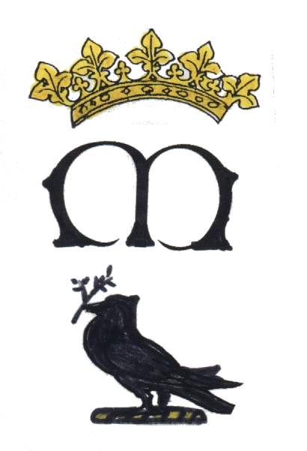
St. Mary’s Catholic Primary School
Hall Road, Scarisbrick, Lancashire L40 9QE
Tel No: 01704 880626
Acting Headteacher: Mrs Jo Preston, BEd(Hons), NPQSL
“Living and Learning Together—Shining in our Faith”

Dear Parents,

We would like to invite any parents, grandparents, or relatives to surprise your child by being a ‘Mystery Reader’ this term in our classroom. Children LOVE having their family, friends and relatives visit our classroom to share in our learning by reading a favourite story aloud to our class.

Mystery Readers can visit us at 3.00pm Monday to Thursday. However, if a Mystery Reader needs a different time to suit their schedule, we will be glad to accommodate if we can!

Once you’ve signed up for a date to come and read to our class, you can start thinking of a book you would like to bring to read. If you don’t have a book, we will gladly supply one for you. Reading is highly valued in our classroom and inviting parents into our community of readers strengthens the home-school connection that is so important in helping the children grow as readers.

If you or someone in your family would like to participate, please either complete the reply slip or see me at the reception class door. If you wish you can be the mystery reader on one or more occasion. Your child will be SO excited that you or someone in your family participated but remember to keep it ‘top secret’ until your big day arrives! We will then be in touch with you to confirm arrangements.

Thank you in advance for your help with this project.
Miss Wade

Mystery Reader Reply Slip

I would like to be a Mystery Reader for Reception class.

Name: _________________________________________________________

I am available on: ______________________________________________ at 3.oopm.

If you would like to take part in more than one Mystery Reader, please let us know!

