What I will learn:  - To use a variety of different objects to experiment with printing.  - To use different shaped sponges to create a printed picture in the style of Paul Klee (Castle and Sun)  - To find out some facts about the artist William Morris and his printed wallpaper work.  - To create own printing blocks and use these to make own wallpaper designs with a repeating pattern  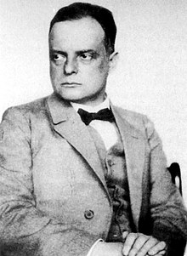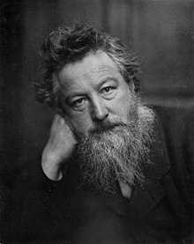  Paul Klee William Morris | ART – Spring 2  PRINTING  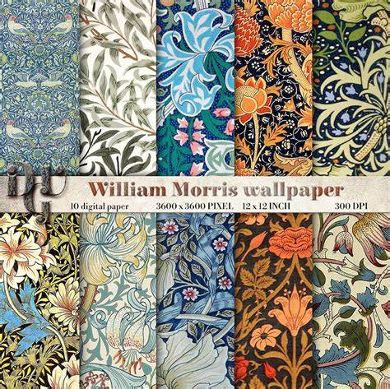  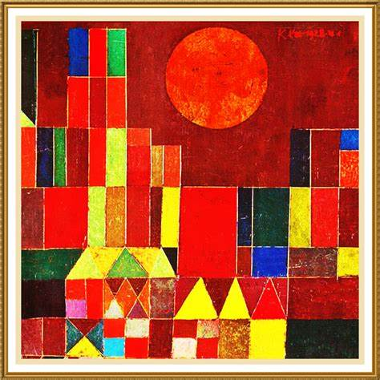 | Vocabulary:  Print – to transfer paint from one item onto paper using different objects and techniques  Printing block – a block with sections of raised areas that is used to print patterns onto paper.  Relief Print – using a block printing technique where the printing block has raised sections.  Wallpaper – paper with a repeated pattern that is used to decorate a wall.  Pattern – a repeated design.  William Morris – British artist who made block printed wallpaper  Paul Klee – a Swiss born German artist who created artwork using printing.
What I will learn:  *Compare and record how things move on different surfaces.  *Understand that some forces need contact but magnetic forces can work at a distance.  *Observe how magnets attract or repel each other and that magnet have two poles.  *Know which poles of a magnet attract and which will repel.  *Can compare and group everyday materials that are attracted by magnets and those that are not.  Scientific Enquiry:  *Ask questions and set up enquiries to answer them.  *Know how to make a fair test and why this is important.  *Make careful observations and record findings.  *Use results to draw and explain verbally simple conclusions.  *To investigate the strength of different magnets. | SCIENCE – Spring 1  Forces and Magnets  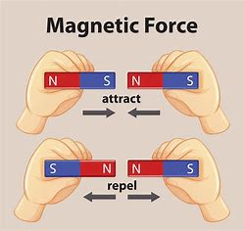  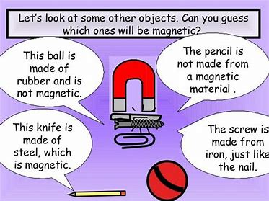 | Vocabulary:  Force – the push or pull on an object to make it change speed  Push – to use a force to move something away from you.  Pull – to use a force to move something towards you.  Surface – to top part or layer.  Magnet – an object that can pull some metal objects towards it  Magnetic material – something that is attracted (pulled towards) a magnet.  Attract – to be pulled towards something.  Repel – to be pushed away from something.  Magnet Poles – The area at the end of a magnet where the magnetic force is the strongest.
What I will learn:  *Name the layers that make up the earth and understand some of their properties.  *Name the key parts of a volcano and explain how it is formed.  *Use world maps to understand where most of the world’s volcanoes are found and how this relates to the tectonic plates.  *Be able to explain what happens when a volcano erupts.  *Be able to explain the risks and benefits of living near a volcano.  *Understand why earthquakes occur and how their strength is measured.  *Understand ways to keep safe during an earthquake and the impact it can have on people and the environment.  *Use geographical vocabulary linked to the topic e.g. continents, countries, physical features. tectonic plates, volcano, earthquake. Extinct, dormant, active.  *Ask geographical questions eg where is the location? What is the landscape like? Why is it like that? | GEOGRAPHY – Spring 1  Earthquakes & Volcanoes  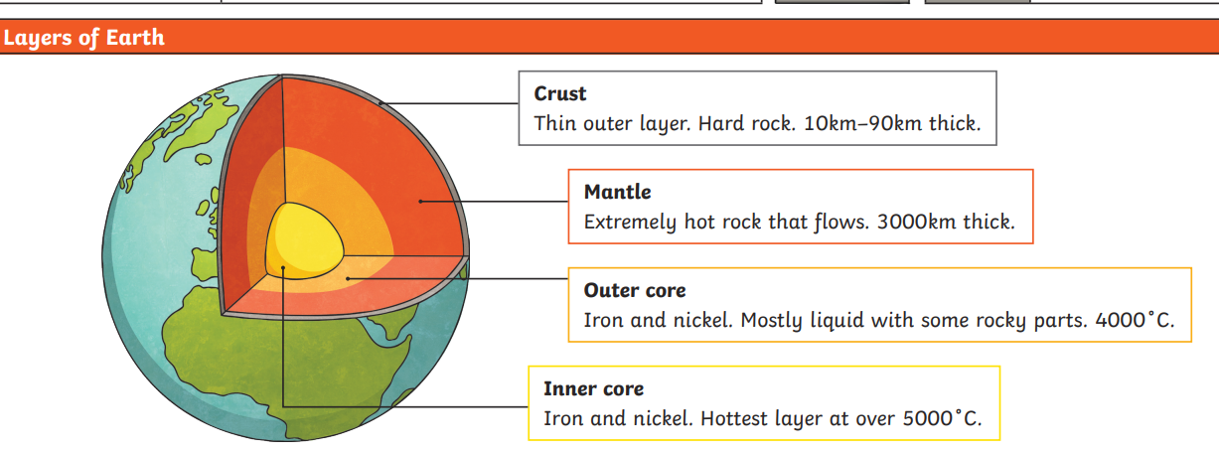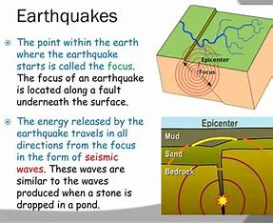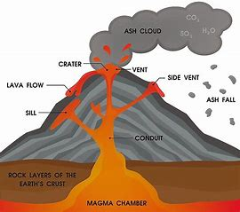 | Vocabulary:  Volcano – a rupture in the earths crust where lava, rock, gas have erupted from.  Earthquake – a movement of the earth when the tectonic plates move  Tectonic plates – the earths crust is made of large plates joined together.  Eruption – to suddenly burst out causing lava to explode out of the earth’s surface.  Magma – extremely hot, liquid rock.  Active volcano – one that has erupted in the last 10000 years.  Dormant volcano – have not erupted in the last 10000years but might erupt again.  Extinct volcano – a volcano that is not expected to erupt.  Physical feature – the features of the land that have occurred naturally  woodland, mountain, valley, beach, lake, river
What I will learn:  - To know the requirements of a plant for life and growth.  - To investigate what happens if a plants needs are taken away.  - Name and describe the functions of different parts of a flowering plant.  - To look at how plants make their own food.  - To investigate how water is transported within plants and the parts involved.  Scientific Enquiry:  *Ask questions and set up enquiries to answer them.  *Know how to make a fair test and why this is important.  *Make careful observations and record findings.  *Use results to draw and explain verbally simple conclusions. | SCIENCE – Spring 2  Plant Structure / Water Transportation  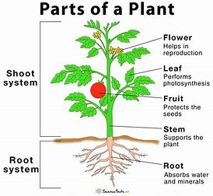  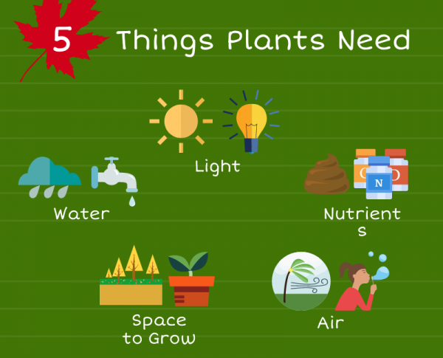 | Vocabulary:  Stem / trunk – the main body of a plant.  Leaves – the flat structure attached to the stem of a plant  Flowers – the seed bearing part of a plant.  Roots – the part of the plant that attaches it to the ground.  Seed – the part that will develop into a new plant.  Bulb – an underground storage organ that can lay dormant under the ground through winter.  Water transportation – The way that water moves around a plant.
What I will learn:  - To communicate ideas about the past using different genres of writing, drawing, diagrams, story -telling and drama.  - Be able to locate the Romans in Britain on a timeline with other significant times / events.  - Use different sources to find and record information about the Roman invasion in Britain and the changes that occurred.  - To find out how and why the Romans invaded Britain?  olyujhhh  - To research what the Roman army was like?  - To explore how things that the Romans introduced changed life today? | HISTORY– Spring 2  Roman invasion of Britain / Power of the Army  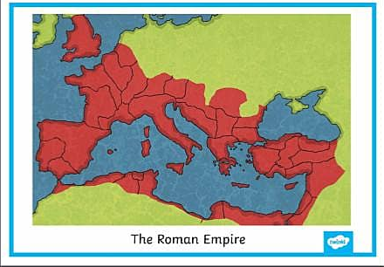  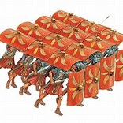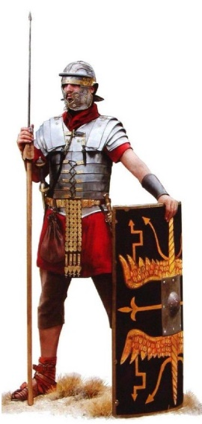 | Vocabulary:  Romans – people from Rome in Italy.  Invasion – To enter another country and fight to take control of it.  Roman Army – the Roman soldiers who fought and invaded other countries.  Legion – a large section of the Roman army made up of about 5000 soldiers.  Conquest – To take control of a place by force, often with an army.  Roman Empire – all the land controlled by the Romans.  Emperor – The ruler of an Empire.  Rebellion – an uprising or revolt by people who want to challenge what they believe is unfair treatment by the rulers.
What I will learn:  - Understand how key events and people in DT can help to shape the world.  - Look at kites, their structure, materials, etc in order to help with own designs.  - Create designs using sketches, diagrams and annotations to show ideas  - Safely measure, cut and shape materials using a range of tools  - Look at ways to create frame structures and add support were necessary  - Evaluate and assess final products and consider how they can be improved or adapted. | DT – Spring 1  Frame Structures – KITES  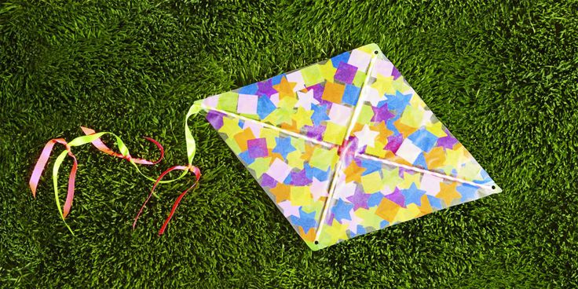  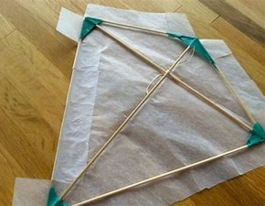 | Vocabulary:  Design – to plan a product before it is made  Design criteria – the list of things that the design should have to be successful  Evaluate – to look at a finished product and assess it against the design criteria  Strengthen – to make something stronger  Frame – a rigid structure that provides support  Material – the substances that objects are made from  Card, paper, tape, string, tissue, crepe, plastic

