What I will learn:  - To understand the primary colours and how these can be mixed to create secondary and tertiary colours.  - To use black and white to create different shades of the same colour.  - To find out some facts about the artist Claude Monet and his work.  - To create own artwork in the style of Claude Monet.  - To evaluate own artwork and think of ways to improve in the future. | ART – Summer 1  PAINTING  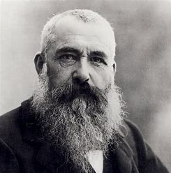  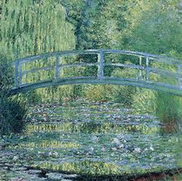 | Vocabulary:  Paint – to use paint to create pictures.  Primary colour – colours that cannot be made from other colours (red, blue, yellow)  Secondary colour – colours that can be made from two primary colours.  Tertiary colour – colours that are made form a mixture of primary and secondary colours.  Impressionism – painting what is seen out of doors and not using sketches or drawing first.  Claude Monet – a French painter who started impressionism.
What I will learn:  - To explore the parts of flowers that take part in the lifecycle of a flowering plant.  - To be able to explain each part of the lifecycle of a flowering plant.  - To understand how pollination occurs and why it is necessary to plants.  - To understand how seeds are formed in plants.  - To understand different forms of seed dispersal. | SCIENCE – Summer 1  PLANTS  Lifecycles & Reproduction  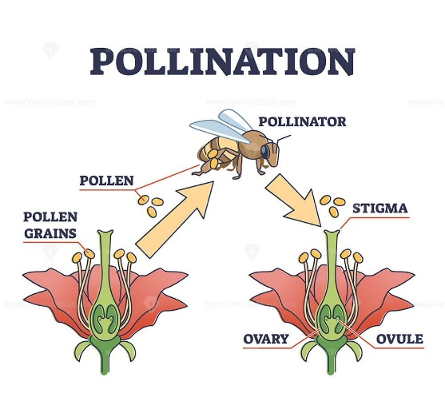  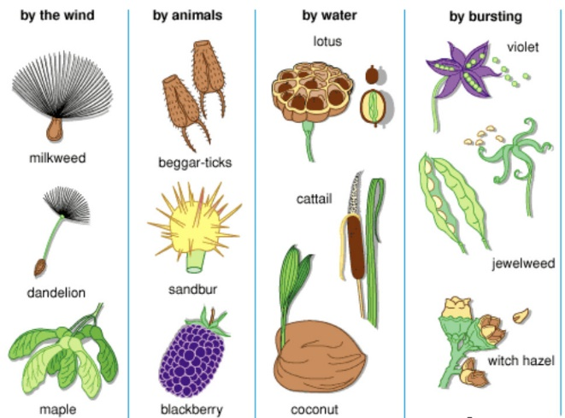 | Vocabulary:  Lifecycle – the cycle that shows the development of a plant through its life.  Stamen - the male part of a flowering plant.  Carpel – the female part of a flowering plant.  Pollination – the process that allows seeds to be created in a plant.  Seeds – the part of a plant that goes on to be a new plant.  Dispersal – the method of moving something to a new place.
What I will learn:  - Collect information on minibeasts to design own bug project.  - To create simple designs for own project and list resources needed.  - To use a simple pattern to cut own bug design  - To use a variety of sticking, pinning and sewing methods to connect materials.  - To evaluate finished products and offer suggestions for improvements. | DT – Summer 2  Textiles - Sewing  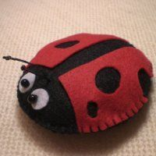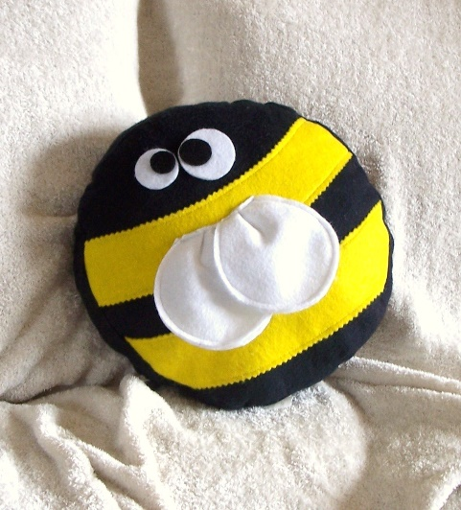 | Vocabulary:  Design criteria – the list of things that the design should have to be successful  Design – to create a new product using own ideas.  Sewing – to attach materials using a needle and thread.  Evaluate – to look at a finished product and assess it against the design criteria
What I will learn:  - To understand how to group animals in different ways.  - To use classification keys to group, identify and name organisms.  - To know different habitats and the animals that live in them.  - To recognise that environments change and this impacts on the living things there – Human population / litter / deforestation  Scientific Enquiry:  *Ask questions and set up enquiries to answer them.  *Know how to make a fair test and why this is important.  *Make careful observations and record findings.  *Use results to draw and explain verbally simple conclusions. | SCIENCE – Summer 2  Living things and their Habitats.  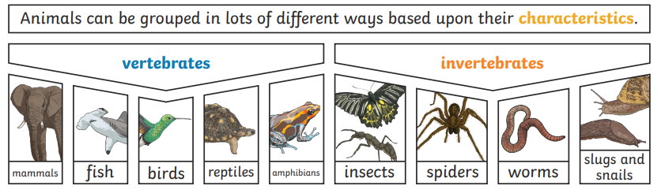  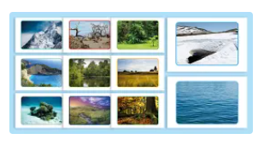  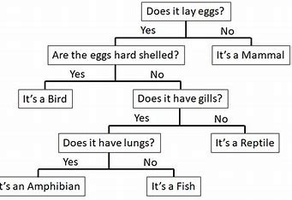 | Vocabulary:  Invertebrates – animals that have no backbone  Vertebrates – animals that have a backbone.  Classification – plants or animals are put into groups depending on their similarities.  Environment -an area made up of different habitats where living things can be found.  Habitat – a specific area where living things like to live.  Impact – when a change happens and this can affect everything in the same area
What I will learn:  Physical Health & Mental Well-being  - To identify how to keep a healthy lifestyle.  - To recognise common illnesses and how they are treated.  - To know how to have good oral hygiene.  - To understand which foods are good or bad for teeth and why.  Journey in Love (Unit 4)  - To know the changes that happen at puberty.  - To understand the importance of personal hygiene during puberty.  Keeping Safe  - To understand how to take medicines correctly and use household products safely.  - To know how cigarettes /vaping /alcohol /medicine can affect us.  - To identify risks with common drugs. | PSHE – Summer 1  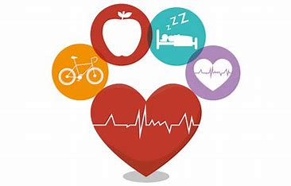  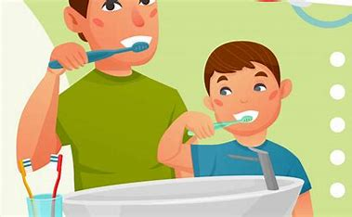  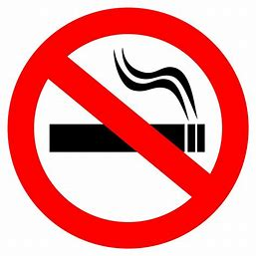 | Vocabulary:  Good Health – being free from illness or injury, feeling well and happy.  Hygiene – maintain good health through being clean.  Oral Hygiene – keeping teeth healthy by being clean.  Risk – a situation that may exposure you to danger  Medicine – legal drugs used to prevent, cure or keep someone free from illness.  Legal Drugs – something that can be bought or prescribed legally but can be bad for you.  Puberty – when there are physical and hormonal changes as a child starts to become an adult.
What I will learn:  - To communicate ideas about the past using different genres of writing, drawing, diagrams, story telling and drama.  - To understand some facts about the city of Liverpool and how it has changed over time.  - To understand what the slave trade was and how Liverpool was involved in this.  - To know some of the important buildings found in Liverpool and when they were built.  - To know some famous people who came from Liverpool and why they are famous. | 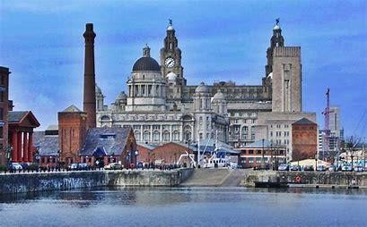  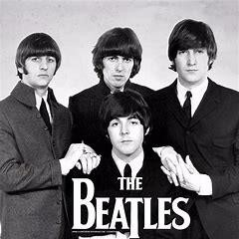 | Vocabulary:  Liverpool – a city in the North West of England.  The Slave Trade – the selling of people to be slaves in a country other than their own.  Slavery – to be held against your will and made to work for someone else.  The Beatles – A pop group who became famous in the 1960s  Impact – having a significant effect on people or a place.  Change – To cause something to be altered  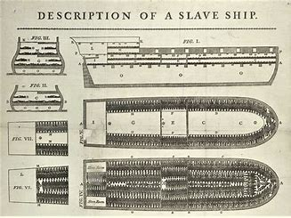
  HISTORY– Summer 2
  Local History Study
  LIVERPOOL
What I will learn:  - To understand the difference between weather and climate.  - To know the symbols used to describe different types of weather.  - To understand the different climate zones that are found around the world and understand the weather seen in different climate zones.  - To understand how to measure different types of weather.  - To understand how different geographical features can affect the weather and climate.  - To understand what the water cycle is and how it works. | GEOGRAPHY – Summer 1  How does weather vary globally and locally and how does it relate to geographical features?  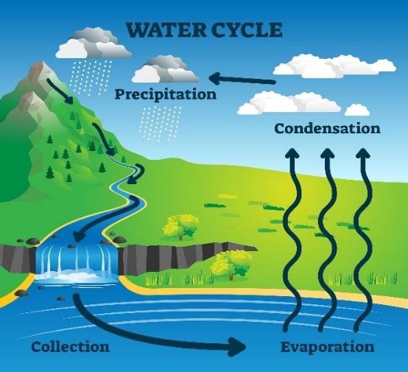  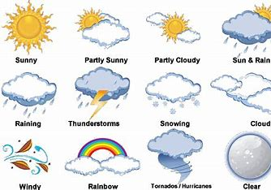 | Vocabulary:  Weather – the conditions in a place at a particular time ie sunny, cloudy, rain, snow.  Climate – the general weather conditions that happen in a place over a long time.  Equator – an imaginary line around Earth that is half way between the poles.  Poles – The top and bottom of the Earth.  Water cycle – how water is recycled.  Evaporation – the process where water turns into a gas.  Condensation – the process where water vapour is changed into a liquid.  Precipitation – water falls back to the earth as rain, snow, sleet or hail.  Collection – when the water collects in lakes, rivers or oceans.

