Class 1 Design Technology Knowledge Organiser
Autumn Term
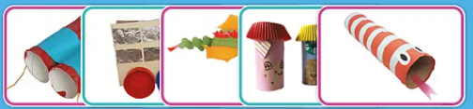 | Structures  3D models – Recycled Materials | 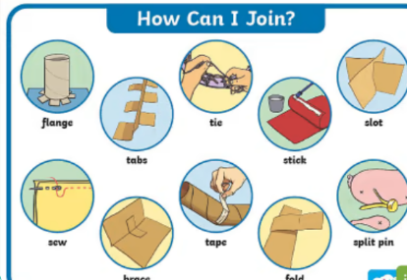
Key Vocabulary  Build - to make by joining together different parts and materials  Layer – something that is spread out over a surface  Join – When you join things, you put or bring them together.  Attach – When you attach two things, you stick them together or you connect them in some way  Cut – to open or break through something with a sharp tool  Recycled – to do something with an object/item that makes it possible to use it again. | What I will learn:  - To collect and explore recycled materials and talk about how they can be stacked, rolled, joined, etc.  - To discuss what kind of models the children would like to create ie animals, fish, buildings.  - To create models using different techniques to cut, join, decorate.  - To talk about models made and evaluate if they fit the design criteria, what could be improved or altered and what worked well.  

